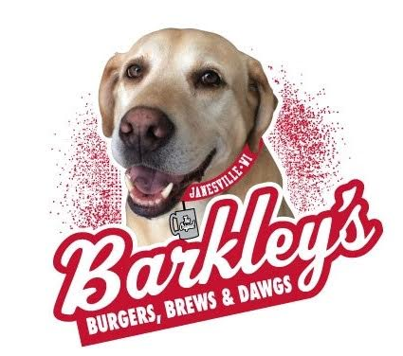

Pet Owner’s Authorization and Release

Pet Owner’s Name
Address
Phone Number
Dog’s Name
Breed
Weight
Age
Your Pet’s Medical Information
Pet owner agrees to maintain copies of all pertinent pet medical information for release to Barkley’s LLC upon request and agrees to the following minimum requirements:
- All vaccinations, including bordetellosis, are complete and current.
- Your pet has no recent history of parasites (6 months) of infection or ringworm.
- Control is being done on a routine basis and your furry friend is free of ticks and fleas.
- Your dog has been fully house trained.
Guidelines
The pet owner associate agrees to observe the following guidelines. Authorization is granted at the sole discretion of Barkley’s LLC and can be revoked at any time.
- Owner will be solely responsible for all clean-up in the pet area and areas outside the building.
- Owner will immediately report any accidents to your server so appropriate clean-up and disinfectant measures can be taken.
- Owner will not bring a dog to Barkley’s that is ill or behaving abnormally and will remove the pet from the premises if any such behavior occurs.
- Owner will not bring a pet to Barkley’s that has bitten or is aggressive, destructive, excessively vocal or fearful.
- Your pet must be leashed and under your control at all times. You will be able to use the leash tether’s provided by Barkley’s as a means of containment while on the terrace.
- Owner must keep a supply of plastic bags with ties at all times and is responsible for the appropriate disposal of pet waste. No pets will be allowed in the following areas: Interior restaurant, food preparation, dining and bar areas, and restrooms
Please check this box if your dog is spayed or neutered

Waiver of Liability
In consideration of being permitted to bring your pet to Barkley’s Burgers, Brews, and Dawgs, Pet Owner does hereby unconditionally RELEASE, WAIVE, DISCHARGE, AND AGREE TO HOLD HARMLESS Barkley’s LLC and Chipper’s LLC, its subsidiaries and/or affiliated companies, their officers, directors, members, agents, servants, associates and/or their representatives (hereinafter referred to as RELEASEES) from any and all liability, claims, demands, actions and causes of actions arising out of or related to any loss, damage or injury, including death, that may be sustained by any person, pet or property WHETHER CAUSED BY THE NEGLIGENCE OF RELEASEES, or otherwise, in connection with or related to associate bringing his (her) pet(s) to the workplace.
Pet Owner further hereby AGREES TO PROTECT, INDEMNIFY AND HOLD HARMLESS RELEASEES from any loss, damage, liability and expense, including court costs and attorney fees, that may be incurred as a result of injuries, including death to persons or pets, or damage to property, directly or indirectly associated with Pet Owner bringing his (her) pet(s) to the workplace, WHETHER CAUSED BY THE NEGLIGENCE OF RELEASEES, or otherwise.
BY SIGNING THIS AUTHORIZATION AND RELEASE, PET OWNER EXPRESSLY ACKNOWLEDGES AND REPRESENTS that he (she) has carefully read the foregoing terms and conditions, understands the contents thereof and signs voluntarily; he (she) is at least eighteen (18) years of age and fully competent; and executes this Authorization and Release intending that he (she), his (her) spouse and family members, and his (her) heirs, assigns and personal representatives if deceased, be legally bound by same.
Pet Owner Signature Date
Barkley’s Approval
I have received the foregoing Authorization and Release from the Pet Owner and am agreeable to Pet Owner bringing his or her pet to Barkley’s Burger, Brew and Dawgs. I approve this request, subject to Pet Owner following the aforementioned guidelines and demonstrating responsible pet ownership.
For:
Signature Managing Member Barkley’s LLC and Chipper’s LLC Date
Original will be kept on file.

